Problem Solving III
Assignment 2
Areesha Raheel
55039
BSIT-6
________________________________________________________________
AVL Tree and Multi-Stage Graph
1. A university wants to maintain a balanced database of student records (ID, Name) using AVL Trees to ensure efficient insertion/deletion.
Task:
Write a program to:
- Insert student records (ID, Name) into an AVL Tree.
- Delete a student by ID.
- Print the AVL Tree in-order.
Input:
insert 101 Alice
insert 102 Bob
insert 103 Carol
delete 102
print
Expected Output:
In-order traversal: [101 Alice, 103 Carol]

CODE:
#include <iostream>
#include <string>
#include <vector>
using namespace std;

class AVLTree {
struct Node {
int id;
string name;
Node* left;
Node* right;
int height;

Node(int i, string n) {
id = i;
name = n;
left = right = nullptr;
height = 1;
}
};

Node* root = nullptr;

public:

int height(Node* node) {
if (node == nullptr)
return 0;
return node->height;
}

int balanceFactor(Node* node) {
if (node == nullptr)
return 0;
return height(node->left) - height(node->right);
}

Node* rightRotate(Node* y) {
Node* x = y->left;
Node* T2 = x->right;

x->right = y;
y->left = T2;

y->height = max(height(y->left), height(y->right)) + 1;
x->height = max(height(x->left), height(x->right)) + 1;

return x;
}

Node* leftRotate(Node* x) {
Node* y = x->right;
Node* T2 = y->left;

y->left = x;
x->right = T2;

x->height = max(height(x->left), height(x->right)) + 1;
y->height = max(height(y->left), height(y->right)) + 1;

return y;
}

Node* insert(Node* node, int id, string name) {

if (node == nullptr)
return new Node(id, name);

if (id < node->id)
node->left = insert(node->left, id, name);

else if (id > node->id)
node->right = insert(node->right, id, name);

else
return node;

node->height = 1 + max(height(node->left), height(node->right));

int balance = balanceFactor(node);

// Left Left
if (balance > 1 && id < node->left->id)
return rightRotate(node);

// Right Right
if (balance < -1 && id > node->right->id)
return leftRotate(node);

// Left Right
if (balance > 1 && id > node->left->id) {
node->left = leftRotate(node->left);
return rightRotate(node);
}

// Right Left
if (balance < -1 && id < node->right->id) {
node->right = rightRotate(node->right);
return leftRotate(node);
}

return node;
}

Node* minValueNode(Node* node) {
Node* current = node;

while (current->left != nullptr)
current = current->left;

return current;
}

Node* deleteNode(Node* root, int id) {

if (root == nullptr)
return root;

if (id < root->id)
root->left = deleteNode(root->left, id);

else if (id > root->id)
root->right = deleteNode(root->right, id);

else {

if ((root->left == nullptr) || (root->right == nullptr)) {

Node* temp = root->left ? root->left : root->right;

if (temp == nullptr) {
temp = root;
root = nullptr;
}
else {
*root = *temp;
}

delete temp;
}
else {

Node* temp = minValueNode(root->right);

root->id = temp->id;
root->name = temp->name;

root->right = deleteNode(root->right, temp->id);
}
}

if (root == nullptr)
return root;

root->height = 1 + max(height(root->left), height(root->right));

int balance = balanceFactor(root);

// Left Left
if (balance > 1 && balanceFactor(root->left) >= 0)
return rightRotate(root);

// Left Right
if (balance > 1 && balanceFactor(root->left) < 0) {
root->left = leftRotate(root->left);
return rightRotate(root);
}

// Right Right
if (balance < -1 && balanceFactor(root->right) <= 0)
return leftRotate(root);

// Right Left
if (balance < -1 && balanceFactor(root->right) > 0) {
root->right = rightRotate(root->right);
return leftRotate(root);
}

return root;
}

void inorder(Node* root) {

if (root != nullptr) {
inorder(root->left);
cout << root->id << " " << root->name << " ";
inorder(root->right);
}
}

void insertRecord(int id, string name) {
root = insert(root, id, name);
}

void deleteRecord(int id) {
root = deleteNode(root, id);
}

void printTree() {
cout << "In-order traversal: [";
inorder(root);
cout << "]" << endl;
}
};

int main() {

AVLTree tree;

tree.insertRecord(101, "Alice");
tree.insertRecord(102, "Bob");
tree.insertRecord(103, "Carol");

tree.deleteRecord(102);

tree.printTree();

return 0;
}

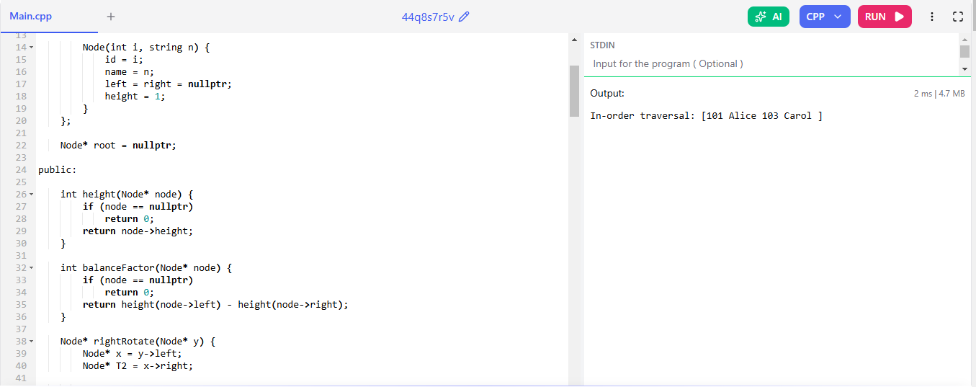

2. Store words in an AVL Tree. Suggest the closest word (alphabetically) if a word is misspelled.
Input:
insert "apple"
insert "banana"
search "appl"
Expected Output
Did you mean "apple"?

CODE:
#include <iostream>
#include <set>
using namespace std;

class WordAVL {
set<string> words;

public:

void insert(string word) {
words.insert(word);
}

void search(string word) {

if (words.find(word) != words.end()) {
cout << "Word found!" << endl;
return;
}

auto it = words.lower_bound(word);

if (it != words.end()) {
cout << "Did you mean \"" << *it << "\"?" << endl;
}
else {
cout << "No suggestion found." << endl;
}
}
};

int main() {

WordAVL tree;

tree.insert("apple");
tree.insert("banana");

tree.search("appl");

return 0;
}

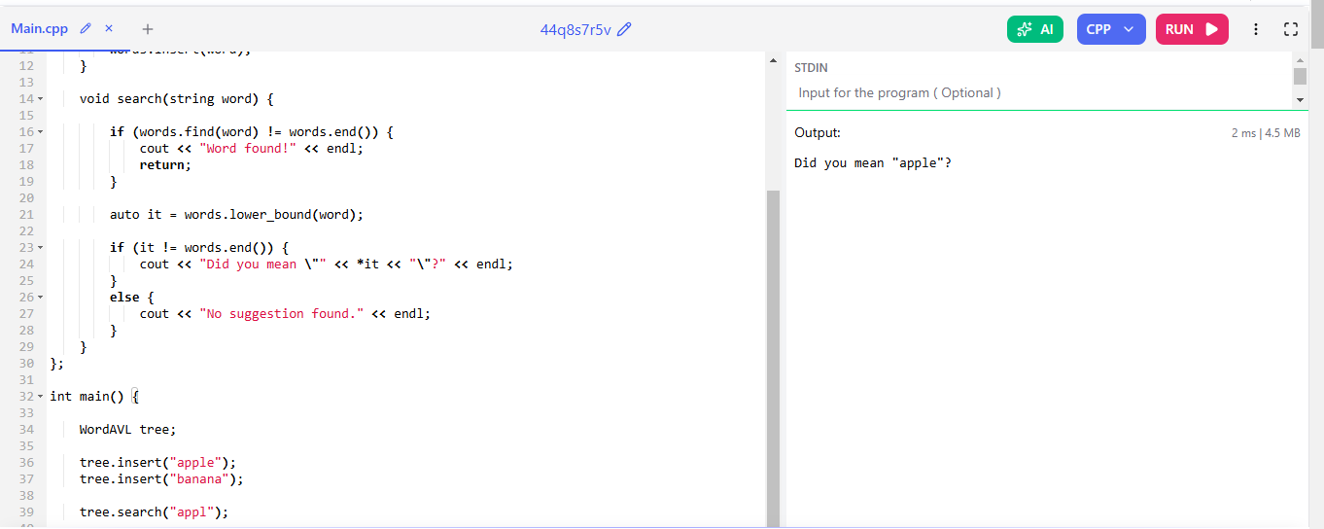

3. Find the shortest path for completing project milestones in stages (e.g., design → development → testing).
Task:
Write a program to:
- Represent milestones as a multi-stage graph (stages = layers).
- Compute the shortest path from Stage 1 to the final stage.
Input:
graph = {
1: [(2, 2), (3, 1)], # (node, cost)
2: [(4, 3)],
3: [(4, 2)]
}
Expected Output:
Shortest path cost: 3 (Path: 1 → 3 → 4)

CODE:
#include <iostream>
#include <vector>
#include <climits>
using namespace std;

const int INF = INT_MAX;

int main() {

int n = 4;

vector<pair<int, int>> graph[5];

// (destination, cost)
graph[1].push_back({2, 2});
graph[1].push_back({3, 1});
graph[2].push_back({4, 3});
graph[3].push_back({4, 2});

vector<int> cost(n + 1, INF);
vector<int> path(n + 1, -1);

cost[4] = 0;

for (int i = n - 1; i >= 1; i--) {

for (auto edge : graph[i]) {

int v = edge.first;
int w = edge.second;

if (w + cost[v] < cost[i]) {
cost[i] = w + cost[v];
path[i] = v;
}
}
}

cout << "Shortest path cost: " << cost[1] << endl;

cout << "Path: ";

int current = 1;

while (current != -1) {

cout << current;

if (path[current] != -1)
cout << " -> ";

current = path[current];
}

return 0;
}




